Host a Ubuntu Virtual Machine using Oracle VM Virtual Box.

Set up Visual Studio code on Ubuntu VM.

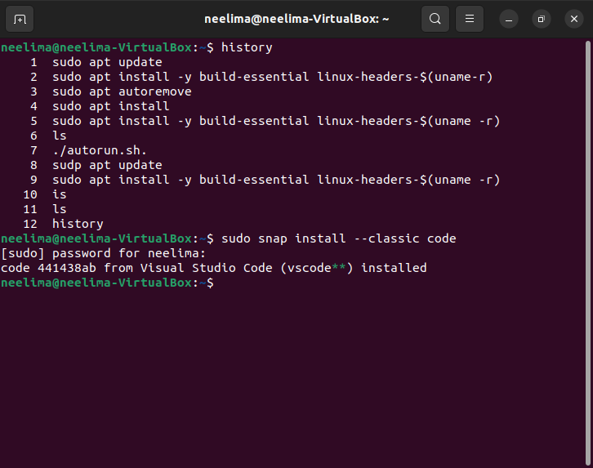

Set up Python.

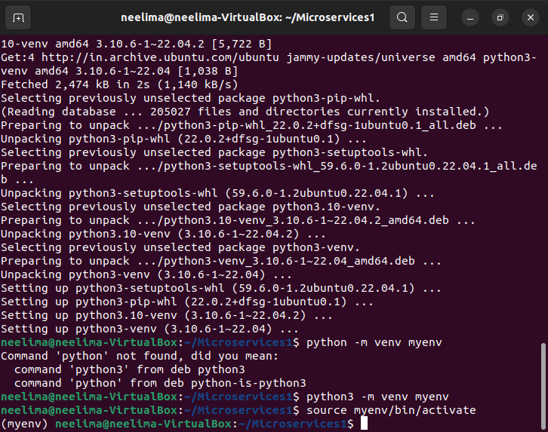

Clone this Github repository<https://github.com/Vikas098766/Microservices.git>

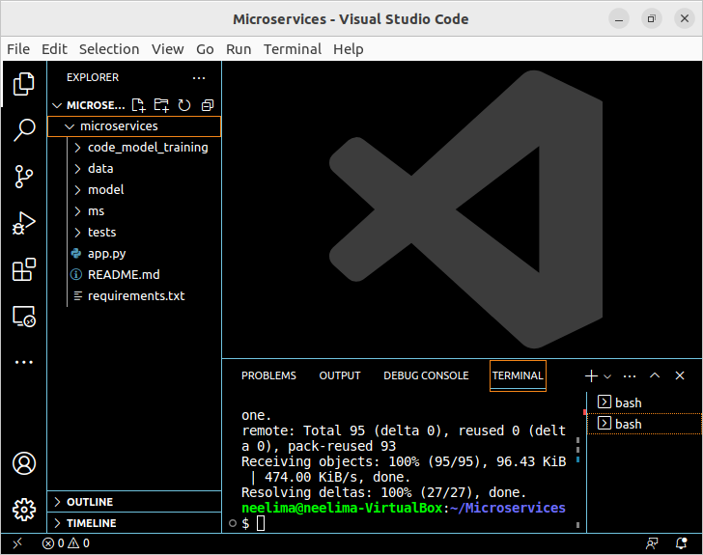

Create a Virtual Environment.

Install the dependencies from requirements.txt file

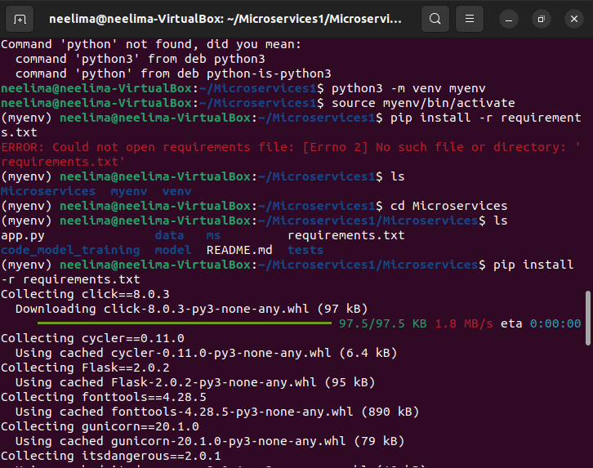

Train and save the model.

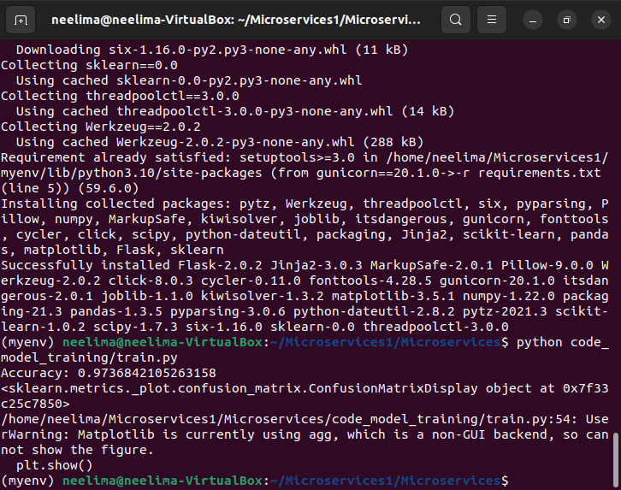

Test the Flask web application.

Test the application and make predictions using the example calls available in the folder/tests.

